PROFILE PAGE:

NAME: john Lloyd

NICKNAME: Cannonball – given for my notorious fast starts and finishes

WHAT ARE YOUR BEST ACHIEVEMENTS??

- Completing every race that I have competed in!!! This has included running Great lakes Fell race (12000 ft of climbing over 17 miles) in conditions where several people dropped out and flooding and footing was a massive problem. Time was not the issue, survivial was !!!

- Coming Second in the White Rose Ultra only 6 days after my PB at Dublin Marathon (2:46)

- Completing 3 marathons in 2 months and defying logic by improving my time by five minutes each time. I am still chasing the elusive 2 hours 45 minutes.

Greater Manchester Marathon 2 hours 57 mins.
Cork City Marathon 2 hours 52 mins
Chester Marathon 2 hours 47 mins

- Losing my weight from 2006 – current time.

The pictures below show all this!!!

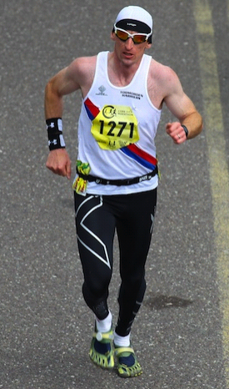
2006 Cragg Vale Fell race Cork Marathon 2012 Cork Marathon
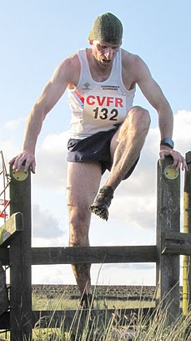
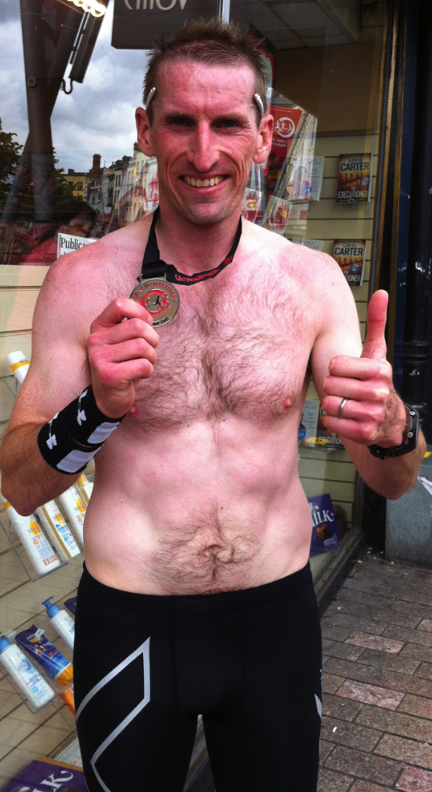

PB times

5k – 16:49
10k – 34: 40
10 mile – 57 minutes 24 seconds
Half Marathon – 1 hour 15 Mins
Marathon – 2 hours 46 mins 23 seconds

Favourite Food

Rib Eye steak, peppercorn sauce, homemade chunky potato chips, mushroom and grilled tomato.

DISLIKES: People laughing at runners, shouting stupid things like “run forest run” or “knees up lad” or people making others feel uncomfortable, especially men shouting / whistling at ladies. Believe it or not I still get daft comments all the time. All I do is remember that those who criticise are doing it deflect away from themselves.

“Obsessive is what the lazy call the dedicated” …. A very wise person once said.

FAVOURITE MUSIC:

Really varied taste – when I am training I very much pick my playlists based on my mood. If I need uplifting then Nina Simone, Van Morrison or cheesy house/indie music. If I need to really grit my teeth and power it out I would listen to heavy metal – such as Rage Against the Machine, Papa Roach, Metallica. Most of my tempo runs I listen to funky house or northern soul. Music is massively important to my training, it helps me work to the tempo I need and makes me forget the pain!!!

FAVOURITE TRAINING SESSION:

Jack Daniels – session from his elite half marathon training plan !!

20 mins 7:20 pace, 4 x 200m 5:20 pace with 1 min easy pace between , 3 x 1000m at interval pace 5:30 with 3 mins easy pace between, followed by 6 sprint strides flat out. 20 mins recovery run.

This is a buffet of running; speed, power, pacing and recovery it’s certainly not boring !

LEAST FAVOURITE TRAINING SESSION:

Any session involving hill reps, necessary but an absolute killer. I sometimes do these on my bike instead as an alternative much more enjoyable for me and equally beneficial.

GOALS FOR FUTURE:

Make my business a success, branch out to other races and even other disciplines including cycling.

Compete in one of the big marathons as a sub 2:45 athlete (I’m nearly there!!)

PERSON WHO INSPIRES YOU:

Anybody who seeks to better themselves!!! People who lose weight, People who don’t’ make excuses.

My Grandmar – the most hardest working and selfless person I will ever have the pleasure of knowing. She never gave up on me and my goals, never made excuses, I miss her but her legacy lives on in me and all my family.
My wife, without her support, love and patience I could not be the person I am today.

On the athlete’s side of things, a life-changing book I read revealed a character called the “ultramarathonman” Dean Karnazes.
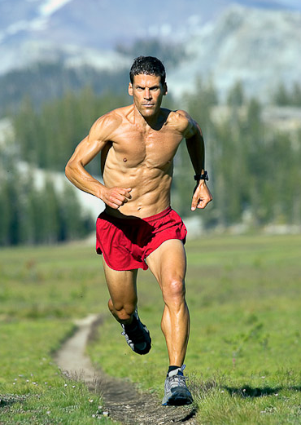

His inspiration shows the heights and goals people can achieve once they have the motivation to do so. In summary he literally set off running one day (Forest Gump style) and didn’t stop until he couldn’t move any further.

On this run he discovered that his mind was free and that his and his families happiness was the most important thing in his life.

He now regularly runs marathons (26.2miles) as warm ups to 100 mile mountain races. Not bad for a guy whom just one day decided running was a good thing to do to release stress.

I cannot do this guy justice you really need to read his book or visit his website. http://www.ultramarathonman.com/web/

